**Problem**

How can we optimize ticket values and facilities so that our profit margin next season reaches past numbers at minimum, despite the steep increase in operating costs this season?

**Goal**

We are seeking to understand which facilities our customers prioritize and how we can use information and market data around ski resort ticket prices in the nation and in our region to optimize Big Mountain’s ticket prices to balance the increase in operating costs at minimum and hopefully increase our profit margins as well.

**PROCESS**

**Model Process**

We first conducted some market research and collected data on ski resorts (consisting of a count and measure of their amenities as well as prices) across the nation to compare Big Mountain to other players in the market. Based on the information gathered, we decided to focus on the price of Adult Weekend ticket prices, though it can be noted that several resorts had different tiers and prices for different types of tickets.

We then conducted an exploratory data analysis where we ran several analyses to understand the summary data, grouped by state. We saw that there was no specific distribution or pattern in the mean Adult Weekend ticket prices by state that we could see based on the count of ticket prices (Figure 1). In general, there did not seem to be a pattern of any sort when we looked at mean ticket prices by state (Figure 2). Thus we decided to treat all states equally.

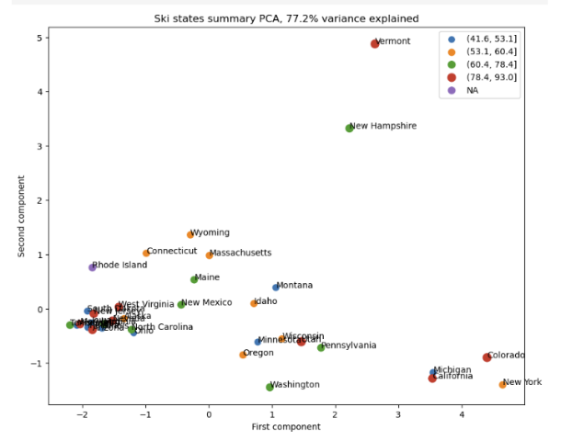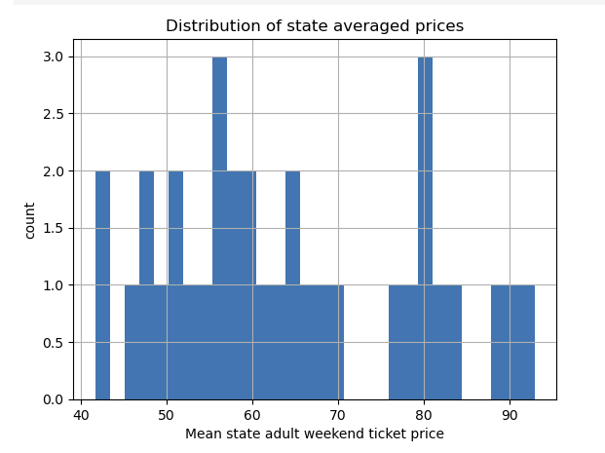

Figure 2

Figure `1

We then created two models—a linear regression and a random forest model—to predict a ticket price based on specific amenities. We trained and tested the model on the data we had previously collected on other resorts, excluding Big Mountain’s data. After assessing both models, the Random Forest Model has a smaller error range, and exhibits less variability. Based on this, we decided to move forward with the Random Forest Model. Based on the model, the dominant top four features that correlate with price are: the number of fast four person chairs (fastQuads), the count of number of runs on the resort (Runs), total area covered by snow making machinese in acres (Snow Making_ac), and the vertical change in elevation from summit to base in feet (vertical_drop).

Big Mountain currently charges $81, but the model suggests that the ticket price could be $95.87 with an error of $10.39, meaning the potential range is around $85 - $106. ticket price and where Big Mountain sits compared to all resorts, Looking at it in comparison to other resorts, we can see that Big Mountain is on the higher end of price tickets in the nation (Figure 3) and at the very highest end for Montana ski resorts (Figure 4).

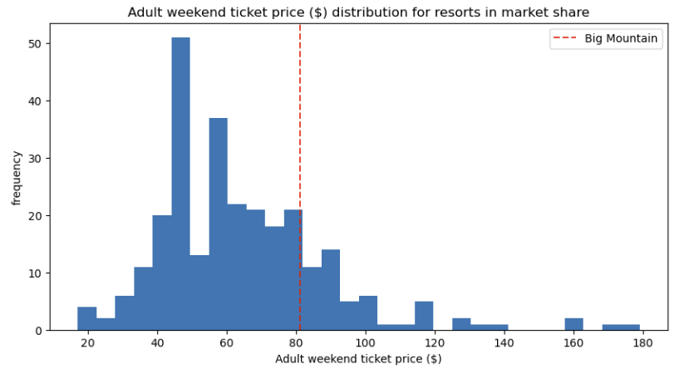

Figure 3

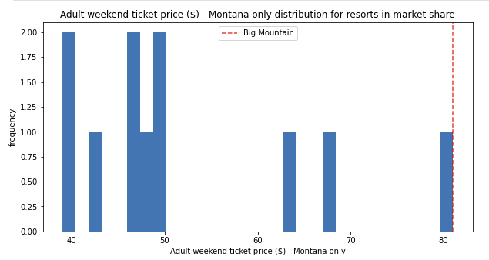

Figure 4

**CONCLUSION**

**Recommendation**

We have an expected 350K visitor with each visitor purchasing on average 5 day tickets. This results in about 1,750,000 tickets The additional operating cost of the new chair lift is $1,540,000. At the very least, we should increase ticket prices by an additional $.88 to cover the operating cost of the new lift or find ways to further decrease our operating costs.

**Risks & Considerations**

While we were given a good foundation in terms of our data, there are some key data pieces we are missing—namely, it would be useful to know how many customers tend to use each of the facilities, how many customers other resorts are getting, and the profit margins for all resorts, from which we can draw more qualitative data. For example, if a resort which is charging higher ticket prices is receiving significantly fewer customers and sees a lower profit margin, that could be a sign that they have overpriced tickets.

Understanding the operating costs would also be helpful so that, rather than using the number of facilities only as indicators of ticket price, we can also understand our profit breakdown more—a lower price could result in higher profits, our end goal, if we are able to severely cut down on operating costs as well.

It is also possible the modeled price was much higher than the current price because some of the other resorts could be severely underpriced or overpriced, affecting our model. We could also be missing several key factors (such as actual usage of these amenities—if Big Mountain has these amenities, but they are not a big draw, then customers are less likely to pay a higher amount for those less attractive amenities. Additionally, number of amenities does not provide information on quality of the amenities). It is important to call out that Big Mountain is already at the higher range of the spectrum but is severely below the modelled price.

**Future Scope of Work**

Using our model, we were able to run several different scenarios in which we adjusted or improved our amenities to see how it affected ticket price—it could be helpful to fully build out this model so that analysts can easily see what price would be appropriate for the amenities available, allowing us to better optimize price. This model would be supported and improved with the addition of operating costs data so that we can better understand not only our revenue, but our profits as well should we make adjustments to our amenities.